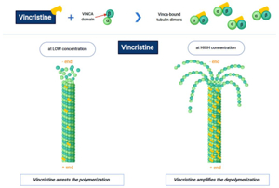
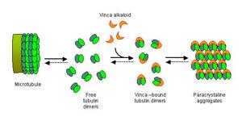
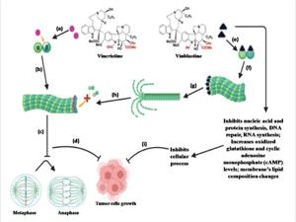
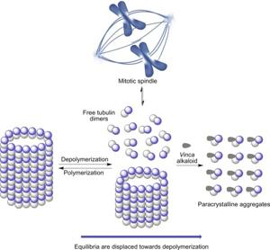
Vincristine is a chemotherapy drug classified as a vinca alkaloid and mitotic inhibitor used to treat various cancers, including leukemia, lymphoma, and solid tumors235.
Mechanism of Action
- Vincristine works by binding to tubulin, a protein required for microtubule formation during cell division132.
- This binding prevents the polymerization of tubulin into microtubules, which inhibits the assembly of the mitotic spindle necessary for chromosome separation at metaphase136.
- As a result, cells are arrested in metaphase of mitosis and undergo apoptosis (cell death)132.
- This mechanism makes vincristine cell cycle phase-specific, primarily affecting cells in the M phase (mitosis), but also impacting the S phase where spindle protein synthesis occurs39.
Clinical Use
- Vincristine is used alone or in combination regimens for cancers such as acute lymphoblastic leukemia, Hodgkin’s and non-Hodgkin’s lymphoma, breast cancer, Kaposi’s sarcoma, and others25.
- It is typically administered intravenously, often through a central line or PICC line to minimize the risk of tissue damage from accidental extravasation5.
Side Effects
- Major side effects are due to vincristine's effects on all rapidly dividing cells, not just cancer cells1.
- Peripheral neuropathy (nerve damage) is the most significant dose-limiting toxicity, presenting as numbness, tingling, motor weakness, and loss of reflexes7.
- Other adverse effects include constipation, abdominal pain, hair loss, jaw pain, leukopenia, anemia, and less commonly, severe neurotoxicity and autonomic dysfunction7.
- Vincristine does not penetrate well into the brain or cerebrospinal fluid, limiting its use for central nervous system malignancies6.
Pharmacology
- Vincristine is largely distributed into tissues and is primarily metabolized in the liver by cytochrome P450 (CYP3A)3.
- It is mostly excreted via the feces, with a smaller portion eliminated in the urine3.
- Oral absorption is erratic and insufficient for therapeutic use3.
Special Considerations
- Vincristine should never be given intrathecally (into the spinal canal) due to the risk of fatal neurotoxicity7.
- Liposome-encapsulated formulations have been developed to improve efficacy and reduce neurotoxicity18.
Summary Table: Key Features of Vincristine
Feature | Description
Drug class | Vinca alkaloid, mitotic inhibitor
Mechanism of action | Inhibits microtubule polymerization, causes mitotic arrest
Main uses | Leukemia, lymphoma, some solid tumors
Administration | Intravenous (never intrathecal)
Major side effects | Peripheral neuropathy, constipation, alopecia, cytopenias
Pharmacokinetics | Liver metabolism, fecal excretion, poor CNS penetration
Vincristine remains a cornerstone of combination chemotherapy regimens, valued for its potent antimitotic activity and established efficacy across multiple cancer types825.
- https://en.wikipedia.org/wiki/Vincristine
- https://go.drugbank.com/drugs/DB00541
- http://www.bccancer.bc.ca/drug-database-site/Drug%20Index/Vincristine_monograph.pdf
- https://www.ncbi.nlm.nih.gov/books/NBK537122/
- https://www.cancerresearchuk.org/about-cancer/treatment/drugs/vincristine
- https://labeling.pfizer.com/ShowLabeling.aspx?id=4653
- https://www.pediatriconcall.com/drugs/vincristine/1045
- https://pubmed.ncbi.nlm.nih.gov/39318002/
- https://www.cancercareontario.ca/en/drugformulary/drugs/monograph/43891

